Research Report: Unrestricted Resource Consumption

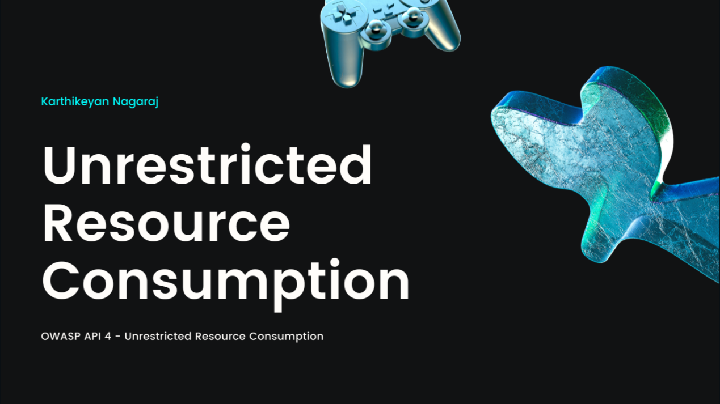

Introduction
Unrestricted resource consumption is a critical issue in software development and system design, where applications or systems fail to enforce appropriate limits on resource usage. This oversight can lead to various problems, including service disruptions, degraded performance, and even complete denial of service (DoS). Understanding unrestricted resource consumption is essential for designing robust, efficient, and secure systems.

What is Unrestricted Resource Consumption?
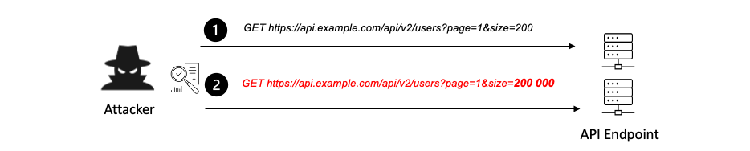
Unrestricted resource consumption occurs when a system allows unlimited use of its resources (e.g., CPU, memory, disk space, or network bandwidth) without applying constraints. This behavior often results from a lack of proper input validation, resource allocation policies, or monitoring mechanisms.

Key Characteristics:
- Lack of Limits: Resources are consumed without predefined thresholds.
- Potential for Abuse: Malicious users or processes can exploit the unrestricted nature to degrade or crash the system.
- Resource Starvation: Legitimate users or processes are denied access to necessary resources.

Common Resources Affected:
- CPU Usage: High computational demands without restriction can exhaust processing capabilities.
- Memory: Excessive memory allocation can lead to out-of-memory (OOM) errors.
- Disk Space: Continuous writing of data without size limits can fill up storage.
- Network Bandwidth: Unchecked traffic can saturate network channels, leading to service unavailability.

Examples of Unrestricted Resource Consumption

Example 1: File Upload Abuse
A web application allows users to upload files but does not restrict the file size or type. An attacker uploads excessively large files, consuming storage space and causing the system to slow down or crash.

Example 2: Infinite Loop API Calls
An API lacks rate limiting and allows unlimited requests. A malicious user sends thousands of requests per second, causing the server’s CPU and memory to become overloaded, leading to a DoS attack.

Example 3: Log File Growth
An application logs all user actions but does not manage the size of the log files. Over time, these logs grow uncontrollably, consuming all available disk space and halting operations.

Case Studies

Case Study 1: GitHub Actions Abuse
Scenario: Attackers used GitHub Actions to mine cryptocurrency by exploiting the system's lack of resource usage restrictions for workflows. By submitting pull requests with mining scripts, they consumed substantial computing power.
Impact:
- Increased operational costs for GitHub.
- Reduced availability for legitimate users.
Mitigation:
- Implementing usage quotas and monitoring workflows for suspicious activity.

Case Study 2: Cloud Resource Exploitation
Scenario: A cloud provider experienced abuse when users deployed virtual machines without limits on resource consumption. Malicious actors used these VMs to run resource-intensive operations such as cryptographic calculations.
Impact:
- Degraded performance for other tenants.
- Increased infrastructure costs for the provider.
Mitigation:
- Enforcing resource limits through quotas and pay-as-you-go models.
- Monitoring for unusual usage patterns.

Case Study 3: Unchecked Chatbot Responses
Scenario: An AI-based chatbot allowed unrestricted input length, leading to excessively large conversations that consumed memory and CPU resources.
Impact:
- Slower response times.
- Service unavailability during peak usage.
Mitigation:
- Restricting input length.
- Setting maximum resource thresholds for individual sessions.

Best Practices for Mitigating Unrestricted Resource Consumption
- Set Resource Quotas: Define limits for CPU, memory, disk, and network usage at the application and system levels.
- Input Validation: Restrict the size, type, and frequency of inputs to prevent abuse.
- Rate Limiting: Implement mechanisms to cap the number of requests or actions per user or IP address.
- Monitoring and Alerts: Continuously monitor resource usage and configure alerts for abnormal patterns.
- Graceful Degradation: Design systems to maintain partial functionality under high load conditions.
- Use Sandboxing: Isolate resource-intensive operations to prevent them from impacting other processes.

Conclusion
Unrestricted resource consumption is a prevalent issue with significant potential for harm. By understanding its causes, examples, and real-world impacts, organizations can take proactive measures to prevent exploitation and ensure system stability. Implementing robust resource management strategies is crucial to mitigating the risks associated with this vulnerability.

References
- OWASP Resource Management Cheat Sheet
- "Denial of Service Through Unrestricted Resource Consumption," Security Research Papers.
- GitHub Actions Security Blog: Preventing Abuse in Workflows.

